（1）Blast protein top 5 results
https://www.ncbi.nlm.nih.gov/protein/QIJ70060.1?report=genbank&log$=protalign&blast_rank=1&RID=KKUTRCWU016
RNA-dependent RNA polymerase [Orin narna-like virus]
ORGANISM Orin narna-like virus
Viruses; Riboviria; Orthornavirae; Lenarviricota; Amabiliviricetes;
Wolframvirales; Narnaviridae.
Score | Expect | Method | Identities | Positives | Gaps
183 bits(465) | 1e-51 | Composition-based stats. | 79/103(77%) | 87/103(84%) | 0/103(0%)

https://www.ncbi.nlm.nih.gov/protein/QIJ70059.1?report=genbank&log$=protalign&blast_rank=2&RID=KKUTRCWU016
RNA-dependent RNA polymerase [Orin narna-like virus]
ORGANISM Orin narna-like virus
Viruses; Riboviria; Orthornavirae; Lenarviricota; Amabiliviricetes;
Wolframvirales; Narnaviridae.
Score | Expect | Method | Identities | Positives | Gaps
175 bits(443) | 8e-49 | Composition-based stats. | 77/103(75%) | 85/103(82%) | 0/103(0%)

https://www.ncbi.nlm.nih.gov/protein/URG15843.1?report=genbank&log$=protalign&blast_rank=4&RID=KKUTRCWU016
MAG: RNA dependent RNA polymerase, partial [Leviviridae sp.]
ORGANISM Leviviridae sp.
Viruses; Riboviria; Orthornavirae; Lenarviricota; Leviviricetes;
Norzivirales; Fiersviridae.
Score | Expect | Method | Identities | Positives | Gaps
157 bits(396) | 4e-42 | Compositional matrix adjust. | 79/103(77%) | 88/103(85%) | 0/103(0%)

https://www.ncbi.nlm.nih.gov/protein/URG16528.1?report=genbank&log$=protalign&blast_rank=3&RID=KKUTRCWU016
MAG: RNA dependent RNA polymerase, partial [Leviviridae sp.]
ORGANISM Leviviridae sp.
Viruses; Riboviria; Orthornavirae; Lenarviricota; Leviviricetes;
Norzivirales; Fiersviridae.
Score | Expect | Method | Identities | Positives | Gaps
125 bits(314) | 4e-31 | Compositional matrix adjust. | 61/103(59%) | 70/103(67%) | 0/103(0%)

https://www.ncbi.nlm.nih.gov/protein/DBA06307.1?report=genbank&log$=protalign&blast_rank=5&RID=KKUTRCWU016
TPA_asm: RdRp [Ulva lactuca associated mitovirus 1]
ORGANISM Ulva lactuca associated mitovirus 1
Viruses; Riboviria; Orthornavirae; Lenarviricota; Howeltoviricetes;
Cryppavirales; Mitoviridae; Mitovirus.
Score | Expect | Method | Identities | Positives | Gaps
103 bits(258) | 3e-23 | Compositional matrix adjust. | 53/103(51%) | 64/103(62%) | 0/103(0%)

Among the top 5 list, 2 came from narnaviridae, another 2 came from leviviridae and 1 came from mitoviridae
Analysis:
A BLASTp search of the 103 amino-acid query against the ClusteredNR database recovered only viral RNA-dependent RNA polymerases. The top two hits are RdRps from Orin narna-like virus (family Narnaviridae), with 77% and 75% amino-acid identity over the full length of the fragment (100% query coverage, E-values 10⁻⁵¹ and 10⁻⁴⁹, 0 gaps). Two additional high-scoring matches correspond to partial RdRps annotated from uncultivated Leviviricetes/Fiersviridae viruses, followed by a more distant hit to a mitovirus RdRp (family Mitoviridae) with 51% identity. This pattern places the query RdRp firmly within the Lenarviricota RdRp clade and indicates that it is most closely related to narnaviruses. Given that RdRp sequences in these groups are typically considered different species below ~90% amino-acid identity, the 77% identity to Orin narna-like virus suggests that u249886 represents a novel narnavirus-like species rather than a known virus. Because narnaviruses and mitoviruses are known to infect fungal or protist hosts, the evolutionary placement of this RdRp strongly suggests that the true host of this virus is a micro-eukaryotic organism present in the porcine intestinal microbiome rather than the pig itself.

Now I’m going to pick SRR5368803 as my representative run for sequence/ORF analysis.
*For the 9 SRA runs that contains the same sequence but different different projects (PRJNA237795: pig gut samples; PRJNA716119: human/unspecified gut metagenomes), will consider putting some strain variation analysis if needed

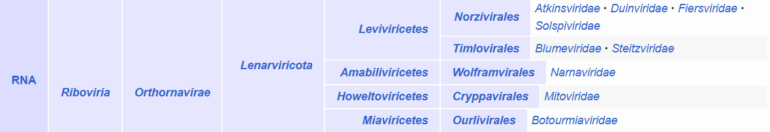
Realm → Kingdom → Phylum → Class → Order → Family → Genus → Species
Riboviria, Orthonavirae, Lenarviricota, Amabiliviricetes/ Howeltoviricetes, Wolframvirales/ Cryppavirales, Narnaviridae/ Mitoviridae

